ECE 445

Senior Design Laboratory

Final Paper

**Electronic Page Turner**

**Team No. 7**

Adia Radecka (aradec2@illinois.edu)

Alyssa Bradshaw (akb5@illinois.edu)

Javi Cardenas (jcarde28@illinois.edu)

**TA:** Raman Singh

**Professor:** Viktor Gruev

May 3, 2023

**Abstract**

The Electronic Page Turner was designed with reading and multitasking in mind. While devices for eBooks already exist, our solution aims to provide a hands-free page-turning device for physical books. Our page turner uses two foot pedals as input and three servo motors to turn pages forward or backward. The servo motors are attached to the base of a wooden stand and a liquid crystal display (LCD) is mounted to a metal enclosure. In this report, we outline the motivation behind our device, design considerations, verifications, results, and improvements. Ultimately, our device was successful in turning pages in both directions, consecutively turning up to 10 pages in a row, and keeping track of how many pages the user has turned.

**Table of Contents**

**1. Introduction**3

1.1 Problem 3

1.2 Solution 3

1.3 High-Level Requirements and Functionality 3

**2. Design**4

2.1 Visual Aid 4

2.2 Block Diagram 5

2.2 Subsystem Overview 5

2.2.1 Power Subsystem 5

2.2.2 Control & Sensor Subsystem 6

2.2.3 Actuation Subsystem 6

**3****. Design** **Verification** 7

3.1 Power Subsystem 7

3.2 Control and Sensor Subsystem 8

3.3 Actuation Subsystem 9

3.4 Tolerance Analysis 10

**4****. Cost & Schedule**11

4.1 Cost Analysis 11

4.2 Schedule 13

**5****.** **Conclusion** 14

5.1 Accomplishments 14

5.2 Uncertainties 14

5.3 Future Work 15

5.4 Ethics 15

5.5 Safety 15

**References**17

**Appendix** 18

# 1. Introduction

## 1.1 Problem

When reading a book, manual page-turning is a crucial requirement. This simple task can inconvenience those wishing to multitask while reading. A prime example occurs when a musician must stop playing their instrument to turn the sheet music when practicing or performing music. Another example is when cooking and using a cookbook; one may not have free or clean hands to turn the pages. Furthermore, a group to consider is those with disabilities who cannot physically turn a book's pages [1]. These are just a few examples of electronic page-turners’ usefulness, but not many exist. Those that do are generally expensive and typically designed for electronic tablet reading. Another issue with existing page-turners for physical books is that they are made for a limited number of pages and can only turn them in one direction. They also require a lengthy setup to attach each page to the device, which is an issue for those wanting to use a book with more pages than the device can handle.

## 1.2 Solution

To solve this problem, our team aims to create a hands-free electronic page-turner that functions with a foot pedal. The device uses two foot pedal switches to turn a page forward or backward. When the foot pedal is pressed, the control system communicates with the motors to start turning a page. A rubber tip attached to the end of a motor is used to lift a single page at a time. A rod connected to another motor will sweep underneath the raised page, causing it to turn to the next page. Our solution is unique because the device does not require extensive setup and can go through all the pages in a physical book in both directions.

## 1.3 High-Level Requirements and Functionality

For our solution to be considered successful, it must achieve the following three goals:

* The device must be able to turn one page within 5 seconds ± 2 seconds. This motion should be repeatable for turning a page backward.
* The device must be able to turn at least ten consecutive pages, with 95% ± 5% accuracy, and take at most 1 minute ± 10 seconds when the foot pedal is pressed consecutively.
* The device must be able to store the total number of pages turned in a single sitting, with 95% ± 5% accuracy, and display this information to the reader.

To use the device, the user first needs to place a book onto the book stand and power the device using the provided wall adapter. The device waits for the user to press one of the foot pedals. Pressing the left foot pedal turns the page backward and decrements the turn counter shown on the LCD. Similarly pressing the right foot pedal turns the page forward and increments the turn counter. The pages are turned by using the servo motors located at the bottom of the stand. The corner motors use a 1.5 inch metal rod with a rubber tip attached for lifting the page up vertically. The center motor has a 4 inch metal rod attached and turns the page over once it has been lifted by one of the corner motors. This system is depicted in our visual aid, which is shown in Figure 1.

# 2. Design

## 2.1 Visual Aid

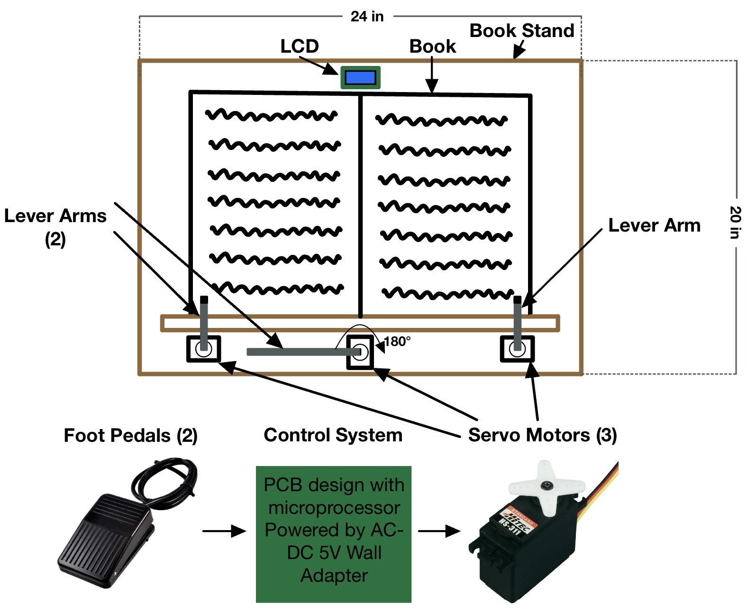

Figure 1: Physical Design

## 2.2 Block Diagram

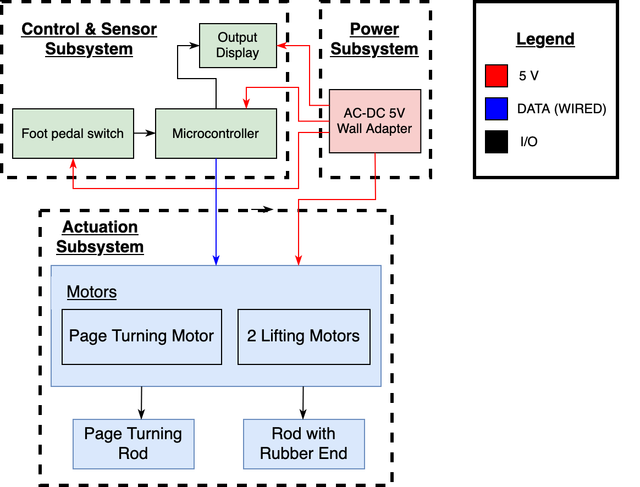

Figure 2: Block Diagram for Electronic Page Turner

## 

## 2.3 Subsystem Overview

Our design is divided into three subsystems: Power, Control & Sensor, and Actuation subsystems, as shown in Figure 2.

### 2.3.1 Power Subsystem

The power subsystem includes a AC/DC power adapter, as seen in Figure 3, that converts 120 AC voltage from an outlet to 5V ± 5% DC voltage. The power adapter is used to send power to the rest of the components in the Control & Sensor and Actuation subsystems.

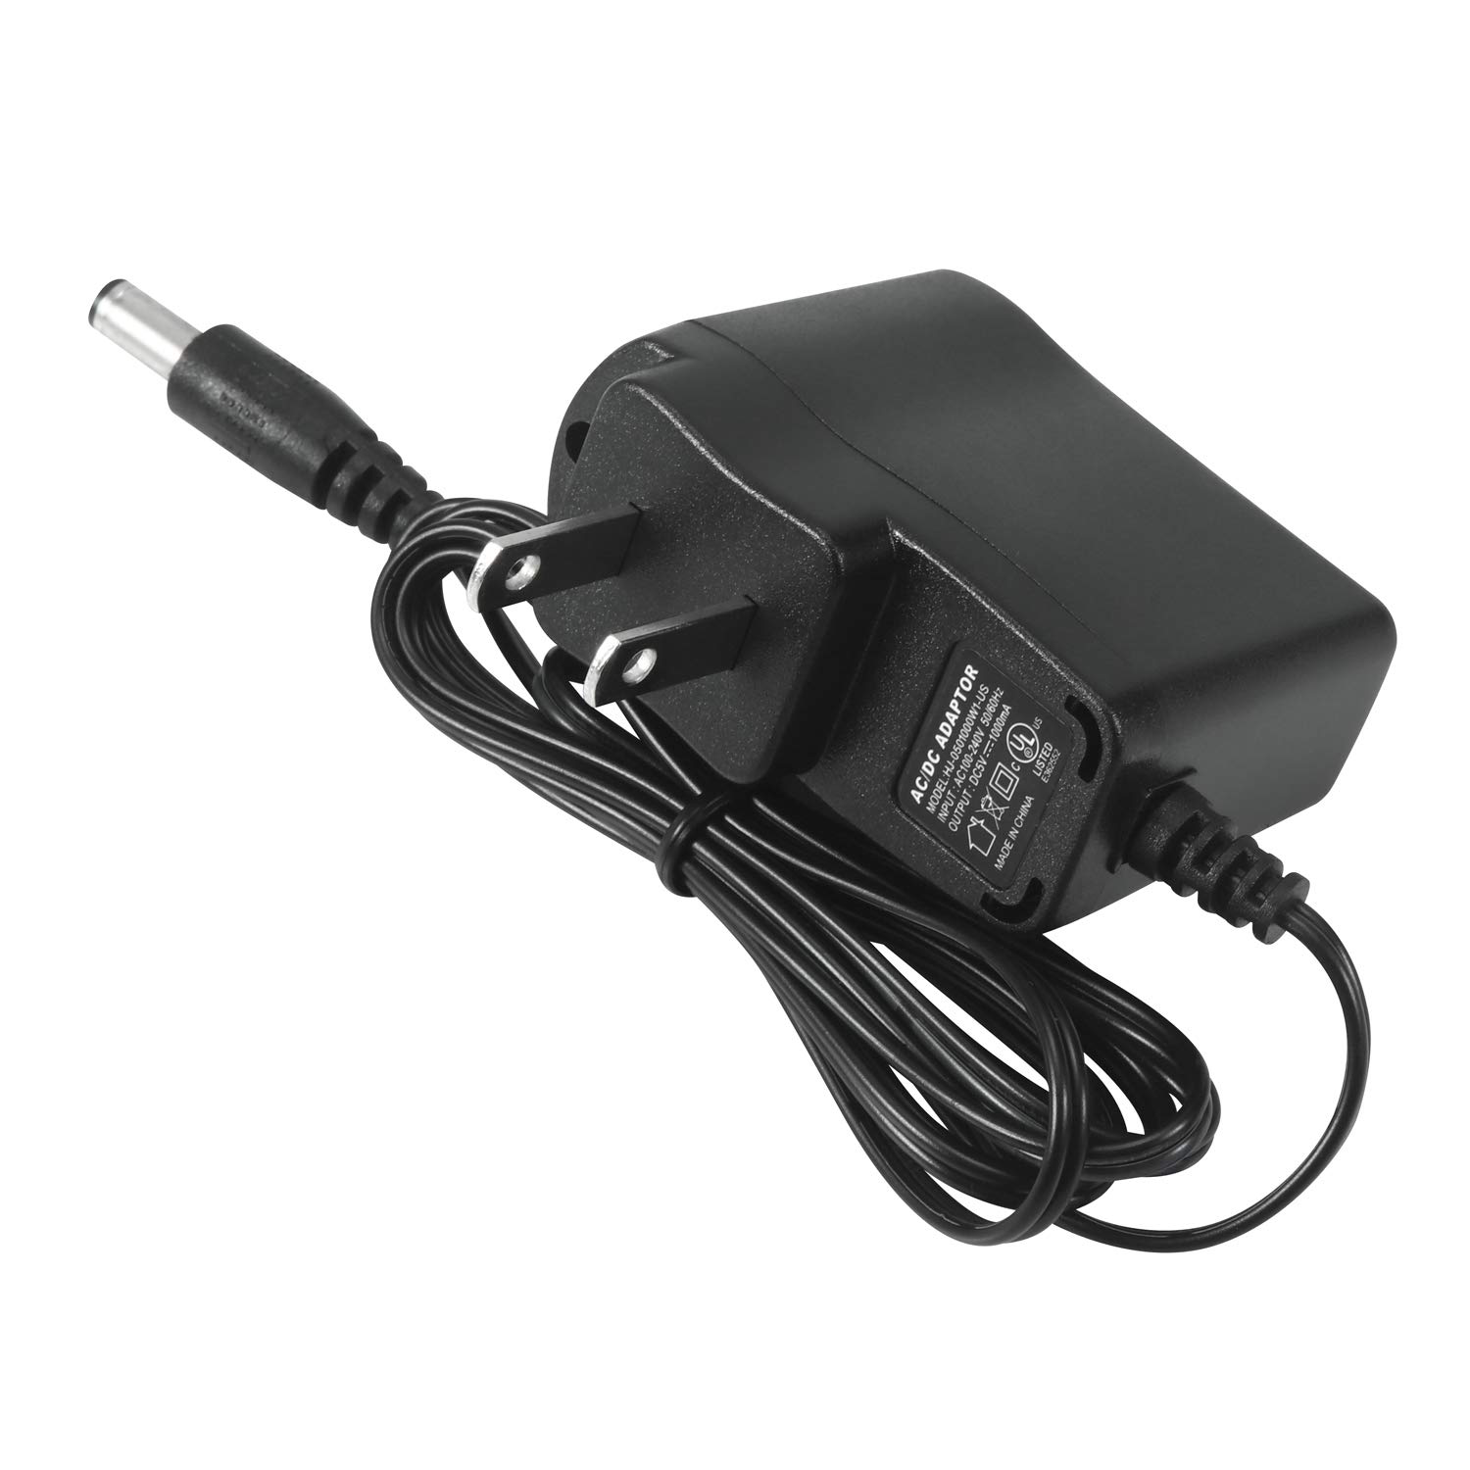

Figure 3: 5V Power Adapter

### 2.3.2 Control & Sensor Subsystem

The control and sensor subsystem contains the microcontroller and sensors needed to move the motors. This includes the ATMEGA328P microcontroller [2], two Twidec foot pedal switches, and an LCD from Focus [3]. All components used in this subsystem can be seen in Figure 4. The microcontroller processes the input signals from the foot pedals and sends output signals to the LCD and servo motors. This subsystem is connected to the power subsystem to operate and the actuation subsystem to send angle data to the servo motors.

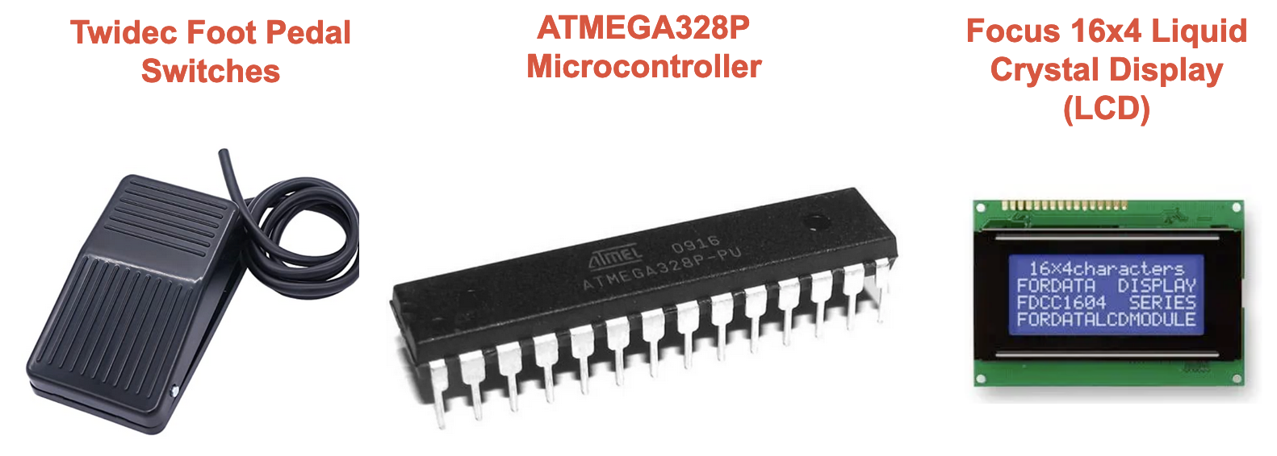

Figure 4: Control & Sensor Subsystem Components

### 2.3.3 Actuation Subsystem

The actuation subsystem contains three servo motors. We used the HS-311 Servo Motors as seen in Figure 5. The two servo motors located on the corners of the stand have 1.5 inch rods with a rubber tip at the end. The center servo motor has a 4 inch rod attached. This subsystem is connected to the power subsystem to operate and the control and sensor subsystem to receive angle data from the microcontroller.

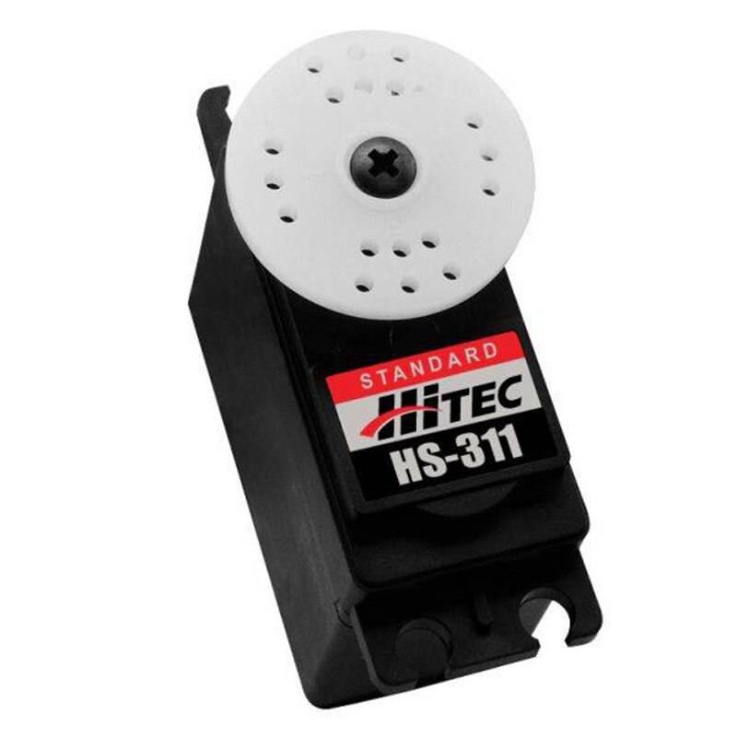

Figure 5: HS-311 Servo Motor

## 3 Design Verification

The requirements for each of our subsystems.

### 3.1 Power Subsystem

The power subsystem handles sending power to the rest of the components in the other two subsystems. For this subsystem, we needed to verify that the 5 volt wall adapter supplies a 5V ± 5% DC to all components when idle and when a foot pedal is pressed. The requirement and verification table is shown in Table 4 under Appendix. This was a vital requirement as all our components need to be supplied with voltage in this range. We verified that the wall adapter supplies 5 volts ± 5% by using a multimeter and an oscilloscope. This was originally tested on a breadboard in the beginning stages of our project. Once we moved to a PCB, we tested this again to ensure that the connection on our PCB was fine. The multimeter displayed a voltage of 5.16 volts when idle and 5.15 volts when a pedal was pressed. We also tested the voltage of the wall adapter using an oscilloscope, as well as all other components. For each test, we stripped two wires and connected those to the voltage and ground lines of the component. We then connected the scope probes to the stripped section of the wire so it would be able to read the voltage data. The sampling rate was set at 500 MS/s and the oscilloscope setup can be seen in Figure 6.

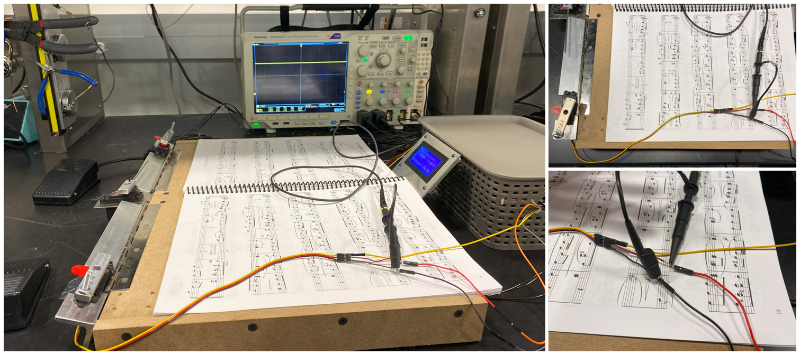

Figure 6: Oscilloscope Testing Setup

We then would power on the device and wait for the voltage to reach 5 volts. We recorded the voltage at idle and then pressed a foot pedal. We recorded the voltage at the time the pedal was pressed. This data can be seen in Table 1 and from this data, it is evident that each component receives 5 volts ± 5%.

| **Component** | **Mean Idle Voltage (V)** | **Mean Active Voltage (V)** |
| --- | --- | --- |
| Power Adapter | 5.215 | 5.185 |
| Left Motor | 5.215 | 5.175 |
| Center Motor | 5.140 | 5.120 |
| Right Motor | 5.130 | 5.130 |
| Microcontroller | 5.200 | 5.150 |
| Left Foot Pedal | 5.200 | 5.170 |
| Right Foot Pedal | 5.145 | 5.135 |
| LCD | 5.200 | 5.140 |

Table 1: Mean Voltage of Components when Idle and Active

### 3.2 Control & Sensor Subsystem

The control and sensor subsystem contains the microcontroller and sensors needed to move the motors. The foot pedal sensor must be able to send a signal when pressed to the microcontroller.The microcontroller must then communicate with the motors to begin turning pages. For this subsystem, we needed to verify that when a foot pedal was pressed, the corresponding motors rotated. This is shown in Appendix Table 5. We also needed to verify that when a foot pedal was not pressed, no motors rotated. We also had to test that the LCD display tracks the correct number of pages total, incrementing for forward and decrementing for backward. This verification process was mostly software oriented, as the programming is what allows the components in this subsystem to communicate. We would test the mechanical system by pressing foot pedals and editing the program until we achieved all the necessary requirements. The final program setup is shown in Figure 7. We also rewired the entire system to make sure all connections were secure. During this process we also discovered that our system would require the use of a second PCB because all the components would not operate using one microcontroller. We had a second working PCB so we connected the right motor and the right foot pedal to the second PCB. We also connected the right foot pedal to the original PCB so the LCD could still receive the signal that a page was turned. The wiring for this system is shown in Figure 8, in Appendix, and the code is shown in Figure 7 located in the Appendix. Figure 9 shows a flowchart of the device’s code. Both PCBs were powered with a 5 volt wall adapter, but they were connected to the same ground. Once the wiring was completed, we tested the foot pedals, motors, and LCD and they all worked as desired. The entire circuit layout and schematic can be found in Appendix , Figures 10 and 11 respectively.

### 3.3 Actuation Subsystem

The actuation subsystem handles the mechanical work of turning the page and includes three servo motors. The motors must successfully lift a page and then turn that page over. This motion must be repeatable for forwards and backward page turning. For this subsystem, we need to first verify that the motors produce a negligible backward EMF. This is shown in Appendix Table 6. We used the same oscilloscope setup as seen in Figure 6. The oscilloscope testing was performed twice, but rewiring occurred before the second trial. In this set of tests, a voltage drop was observed when components were idle and when active, at random times. The voltage drop was at 800 mV ± 5% when seen. Because the voltage drop is less than one volt, it is considered negligible in terms of backward EMF [4]. Although this voltage drop is not an issue, we think this occurred because of a loose connection in the wiring when connecting the scope probes, since this was not seen in the first set of tests. The voltage drop is depicted in Figure 12, where (a) is the voltage at a steady 5 volts and (b) shows the voltage increasing back to 5 volts after dropping 760 mV.

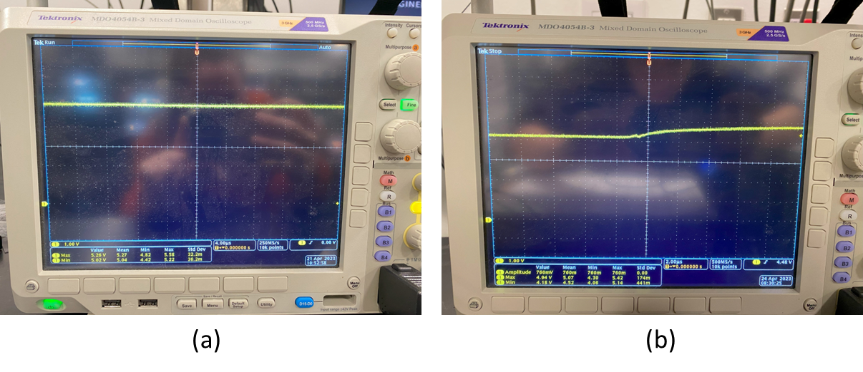

Figure 12: (a) Component Voltage of 5 V and (b) Component Voltage Spike of 760 mV

We also had to verify that the motors did not cause any damage to the pages of the book. When testing, tearing did occur because of the motor angles we were initially using. Originally the middle motor would turn 45° before the lifting motor moved out of the way and this would pull the page too far and rip it. We experimented with different angles for the middle servo motor until we noticed that tearing did not occur. This process is shown in Figure 7, in Appendix. We also added electrical tape to the lever arm of the middle servo motor so that it did not have any rough edges. After fixing the angles and adding the tape, we performed 10 trials and no tearing occurred.

## 

## 3.4 Tolerance Analysis

A crucial part of our project's success is the motors to lift a single page and the center motor to flip the page. We must consider the thickness of a book and how far along into the book we are for the lifting motors to hold a page vertically. For testing, we will be using a music sheet book with the following dimensions: 9 x 0.24 x 12 inches. The lifting motors must reach low enough to grab the very last page of the book, which would be at 0.0025 inches. We determined that the page must be lifted one inch to provide the sweeping rod attached to the center motor enough space to flip the page. Therefore a singular page must be displaced 45°, with respect to, the book if using a one inch rod to lift the page as shown in Equation 1.

${Θ_{page, max}^{}}_{}=tan^{-1}(\frac{1}{1})=45°=0.785 rad$

Equation 1: Angular displacement for a 1 in. rod attached to lifting motor

${Θ_{page, min}^{}}_{}=tan^{-1}(\frac{1}{3})=18.4°=0.321 rad$

Equation 2: Angular displacement for a 3 in. rod attached to lifting motor

${Θ_{sweep}^{}}_{}=180°=3.14 rad$

Equation 3: Angular displacement for sweeping rod attached to center motor

Additionally, two of our high-level requirements involve time. More specifically, the time it takes to flip a single page and to turn ten pages consecutively. According to the datasheet for the motors, the maximum torque each can provide is 5.5 kg/cm = 0.053937 Nm, as shown in Equation 4. Ideally, each motor will receive 600 mW of power, as shown in Equation 5. By finding the maximum angular velocity, in Equation 6, the time it takes for each motor to complete its angular displacement can be calculated as shown in Equation 7. This process will ideally take 423.62 ms (2 X 70.603 + 282.41 ms). While these calculations are under ideal conditions, realistically, we can expect the process to take about 3 seconds as we will have to add five delays of about 500 ms to allow for each motor to complete their full movement. We also have to consider going too fast may cause physical damage to the book’s pages, which we plan to avoid.

$τ_{motor}=5.5 kg/cm = 0.053937 Nm$

Equation 4: Maximum torque provided in motor datasheet

$P_{motor}=I_{motor}V_{motor}$

$P_{motor}=0.1 [A] ×6 [V] = 0.6 W$

Equation 5: Maximum power provided to each motor

$P=τω→ω = P÷τ$

$ω=0.6 [W] ÷0.053937 [Nm] = 11.124 rad/s$

Equation 6: Maximum angular velocity for each motor

$t_{Θ_{page, max}^{}}= \frac{1 s}{11.124 rad}×0.785 rad =70.603 ms$

$t_{Θ_{page, min}^{}}= \frac{1 s}{11.124 rad}×0.321 rad =28.924 ms$

$t_{Θ_{sweep}^{}}= \frac{1 s}{11.124 rad}×3.14 rad =282.41 ms$

Equation 7: Time required for each motor to reach their angular displacement

# 4. Cost & Schedule

## 4.1 Cost Analysis

Production of this device is estimated at 30 hours per week over 15 weeks distributed amongst three people. The team consists of only electrical engineers, and based on our current job offers, the average pay is $40 per hour. Based on this hourly rate, the estimated labor cost for all three team members combined is $18,000. With a 2.5x overhead, this brings the total labor cost to $45,000.

Below we have included a table with the cost of all the parts used in our device. Based on these numbers we estimate a cost of $190.16 for all required components. This brings the total cost for our device to $45,190.16.

| **Part** | **Part Number** | **Unit Price** | **Quantity** | **Total** |
| --- | --- | --- | --- | --- |
| Microcontroller | ATMEGA328P-PU | $7.21 | 2 | $14.42 |
| Foot Pedal | n/a | $10.43 | 2 | $20.86 |
| Servo Motor | HS-311 | $14.76 | 3 | $44.28 |
| PCB Manufacture | n/a | $30.00 | 1 | $30.00 |
| Barrel Jack | PJ-102AH | $0.82 | 1 | $0.82 |
| 5V Wall Adapter | 1470-2771-ND | $6.50 | 1 | $6.50 |
| ISP Header | 1597-114020164-ND | $2.80 | 2 | $5.60 |
| 3 Pin Header | WM4201-ND | $0.27 | 7 | $1.89 |
| LCD Display | 2632-C162A-BW-LW65-ND | $6.27 | 1 | $6.27 |
| 10k Resistor | 2197-294-10-RC-ND | $0.15 | 8 | $1.20 |
| 1uF Capacitor | 478-1836-ND | $0.82 | 9 | $7.38 |
| 2 pin header | 900-0022232021-ND | $0.15 | 2 | $0.30 |
| 12 pin header | 2057-LHA-12-TS-ND | $0.26 | 1 | $0.26 |
| Diode | 1N4148W-13-F | $0.19 | 2 | $0.38 |
| Machine Shop Parts | n/a | $50.00 | 1 | $50.00 |
| **Total Cost** | | | | $190.16 |

Table 2: Total Cost of Required Components

## 4.2 Schedule

| **Week** | **Adia** | **Alyssa** | **Javi** |
| --- | --- | --- | --- |
| 02/20/23 | Work on Design document, team contract, proposal revision and begin working on PCB | Work on Design document, team contract, proposal revision | Work on Design document, team contract, proposal revision |
| 02/27/23 | Design PCB, attend PCB review, and submit the order | Pick up the stand from the Machine Shop | Pick up the stand from the Machine Shop |
| 03/06/23 | Ordered PCB parts | Make physical circuit on breadboard | Work on code for LCD and Motors |
| 03/13/23 | Spring Break | Spring Break | Spring Break |
| 03/20/23 | Solder one PCB | Solder one PCB | Continue working on code for all components |
| 03/27/23 | Design the second PCB and order it and Individual Assignment | Individual Assignment and testing on the physical board | Individual Assignment and debugging. |
| 04/03/23 | Solder the second version of the PCB and help with testing | Solder the second version of PCB and help with testing | Upload code to the microcontroller and do testing |
| 04/10/23 | Work on team contract fulfillment | Work on team contract fulfillment | Work on team contract fulfillment and debugging code |
| 04/17/23 | Help with oscilloscope testing | Conduct oscilloscope testing | Make final changes in code |
| 04/24/23 | Make sure everything is working for Demo and worked on presentation | Make sure everything is working for Demo and worked on presentation | Make sure everything is working for Demo and worked on presentation |
| 05/01/23 | Practice the Final Presentation and work on writing the Final Paper | Practice the Final Presentation and work on writing the Final Paper | Practice the Final Presentation and work on writing the Final Paper |

Table 3: Schedule After Design Review

# 5. Conclusion

## 5.1 Accomplishments

All high level requirements were met and the electronic page turner was able to fully function using foot pedals. The page requirements were met and the device was able to consecutively turn pages with an accuracy of 90%. The final product can be seen in Figure 9 located in the Appendix. Additionally, each page turned took approximately 5 seconds to flip, which is within the range we expected. Outside the high level requirements our device is easy to set up compared to devices available on the market. The ‘automatic electronic book page turner’ that is available requires manual placement of 10 pages into slots [4]. Our device avoids that process by making it automated and simpler.

## 5.2 Uncertainties

The main uncertainty we had was the use of two PCB’s. When we connected all components to our PCB the right motor was running into power issues. Since we had three servo motors connected, we think the two other servos were drawing too much current and dropping the voltage across the right servo motor. One way to mitigate this would have been to add a larger capacitor on the right servo motor’s power line. While we did not have enough time to implement this solution, the temporary solution we came up with was to include another PCB that would have one motor and one foot pedal connected to it. This would allow for the second PCB to have its own separate power source. The PCB’s shared a common ground and the output line of the foot pedal. Since the device worked as expected with two PCBs we determined that we could move forward with this solution.

## 5.3 Future Work

There are a few additions and adjustments that could be made to our device. A few issues we encountered were multiple pages jamming the motors, a motor lifting multiple pages, and a motor missing a page. To fix these issues we would like to add a force sensor to the left and right lifting motors. Since the lever the motors used to lift a page are static they can not sense when the book has begun to thin out or if it is too thick to lift. Including a force sensor would increase the accuracy of the device and make the experience more enjoyable for the reader. To fix page jamming we would like to incorporate a feedback loop or reset button that would move the motor back to its home position. This would lay the jammed pages back down and allow us to turn them again one by one. We can also reduce the overall cost of our device by using one PCB and power supply.

## 5.4 Ethics

The IEEE code of ethics lists a few policies that should be considered while working on this project. Policy 1.5 states “to seek, accept, and offer honest criticism of technical work, to acknowledge and correct errors, to be honest and realistic in stating claims or estimates based on available data, and to properly credit the contributions of others''. [6] This policy applies to this project because page-turners are currently available. We will adequately credit any work done on page-turners and build upon those ideas. Additionally, criticism and new ideas will be welcomed so that our project development process is rewarding.

## 5.5 Safety

Although our project is a hands-free device, there is a possibility of injury if any bodily parts interfere with the device while it is in motion. The rods attached to the motors will perform a sweeping action to turn the pages. While there is not enough force to cause severe injury, placing your hand in the way while the rod is in motion may hurt. We need to keep in mind the rod's material and the speed of the motors so that if contact does occur, it will not cause any severe damage. Setting the correct speed is also important to avoid tearing or damage to the pages of the book. If the speed is too fast, the force of the rods can cause damage to the book. To prevent this from occurring, we plan to tune the parameters in the software accordingly. Ideally, the slowest speed that still turns a page will be chosen to avoid any safety issues. Also, if someone has their hands in the way and causes the motor to stall, this will cause the motor to heat up. Although unlikely, this could potentially cause a burn to the individual.

Another potential danger could be from the power subsystem. Although our device does not require high voltage to operate, we will use a wall power adapter which creates the issue of electric shock. Electric shock occurs when current flows through your body. The larger the voltage, the more current there is and the worse the shock could be. An electric shock can occur if you touch the live and neutral wire of the power supply as you become a part of the circuit and allow current to flow through you. It is essential to be mindful of this connection and not to touch the leads of these wires when plugged into the power supply. It is also crucial to ensure none of the equipment is faulty as this can cause electric shock. Faulty equipment includes but is not limited to damaged wires, damaged plugs, broken connections, wet plugs, and plugs with missing prongs[7]. Before using any equipment, our team will take the mandatory high voltage safety training and plan to keep this training in mind as we work on our project to avoid the danger of electric shock. We will also implement the one-hand rule to prevent current from flowing into your body and out the other connection point. We will also check to make sure all equipment is undamaged before use.

# References

[1] “Assistive Technologies for Reading,”ASCD, Dec-2005. [Online]. Available: <https://www.ascd.org/el/articles/assistive-technologies-for-reading>. [Accessed:06-Feb-2023]

[2] Atmel Corporation, “ATmega328P 8-bit AVR Microcontroller with 32K Bytes In-System Programmable Flash DATASHEET,” 2015 [Online]. Available: <https://ww1.microchip.com/downloads/en/DeviceDoc/Atmel-7810-Automotive-Microcontrollers-ATmega328P_Datasheet.pdf>. [Accessed: 06-Feb-2023].

[3] K. Söderby, “Liquid Crystal Displays (LCD) with Arduino | Arduino Documentation,” *docs.arduino.cc*, Nov. 18, 2021. [Online]. Available: <https://docs.arduino.cc/learn/electronics/lcd-displays>. [Accessed: 01-March-2023].

[4] ServoCity, “HS-311 Servo-Stock Rotation,” *ServoCity*. [Online]. Available: [https://www.servocity.com/hs-311-servo/.](https://www.servocity.com/hs-311-servo/.%5BAccessed) [Accessed: 01-March-2023].

[5] “Automatic Electronic Book Page Turner Device for the Disabled,” *Rehabmart.com*. [Online]. Available: <https://www.rehabmart.com/product/automatic-page-turner-29652.html?gclid=CjwKCAjwo7iiBhAEEiwAsIxQEe4b7mDnafVDfNyEwo7n13bhtNdDL9WzMFQlxUvA-Q9HfNfL>

[9yxcKxoCZ6UQAvD_BwE](https://www.rehabmart.com/product/automatic-page-turner-29652.html?gclid=CjwKCAjwo7iiBhAEEiwAsIxQEe4b7mDnafVDfNyEwo7n13bhtNdDL9WzMFQlxUvA-Q9HfNfL) .[Accessed: 16-Feb- 2023]

[6] “IEEE code of ethics,” IEEE, Jun-2020. [Online]. Available: <https://www.ieee.org/about/corporate/governance/p7-8.html>. [Accessed:06-Feb-2023].

[7] C. C. for O. H. and S. Government of Canada, “The Young Workers Zone : Teaching Tools : Physical hazards: Electrical,” *The Young Workers Zone : Teaching Tools : Physical Hazards: Electrical*, 12-Jul-2010. [Online]. Available: <https://www.ccohs.ca/teach_tools/phys_hazards/electrical.html>. [Accessed: 23-Feb-2023].

‌

**Appendix**

| Requirements | Verification |
| --- | --- |
| * Must have a 5V wall adapter that plugs into a wall outlet. * All components must be supplied with 5 V ± 5%, when the devices are idle and when active. | * Use a multimeter to check that the wall adapter’s barrel jack is supplying a steady 5V ± 5%. * While the device is turned on, measure the voltage across each device using an oscilloscope. Repeat this process when a foot pedal is pressed. |

Table 4: Power Subsystem R&V Table

| Requirements | Verification |
| --- | --- |
| * When the left foot pedal is pressed, the corresponding motors to turn a page backward should rotate. When the right foot pedal is pressed, the corresponding motors to turn a page forward should rotate. * LCD Display must track the number of pages turned forward. | * Test the situation where the foot pedal is not pressed. Ensure that the motors do not rotate. * Test the situation where the foot pedal is pressed. Ensure that the lifting motors rotate 0°-45°-0° and the center motor rotates 0°-90°-180°. * When a page is turned forward, the count should increase by 1. If a page is turned backward, the count should decrease by 1. |

Table 5: Control and Sensor Subsystem R&V Table

| Requirement | Verification |
| --- | --- |
| * The servo motors must create negligible backwards EMF. * The motors should cause minimal to no damage or tearing to the pages in the book. | * Use an oscilloscope to plot the voltage of a motor when idle and when active. If the voltage spike is less than 1V ± 0.5V we can consider the backwards EMF from the motor negligible. Otherwise, we will add more capacitors and diodes to prevent negatively impacting the other hardware in our device. * Run 10 test trials to find the best angle and speed for each motor. |

## Table 6:Actuation Subsystem R&V Table

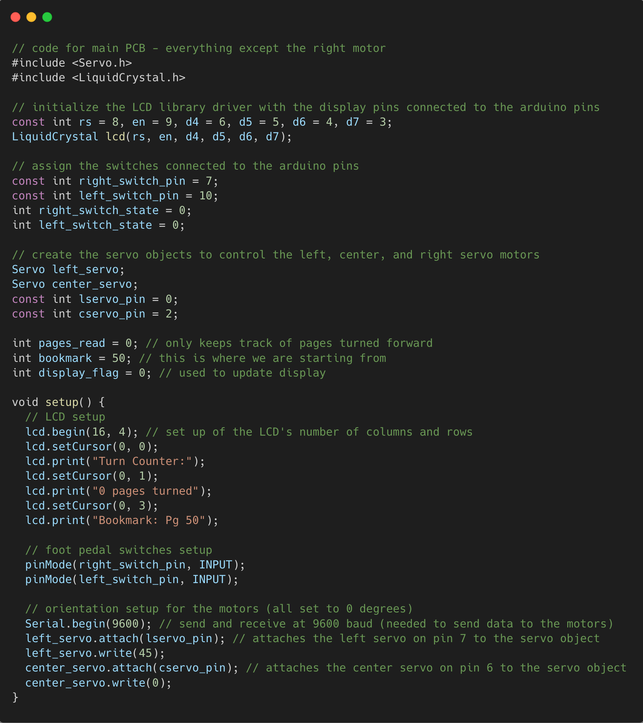

Figure 7: Device Code

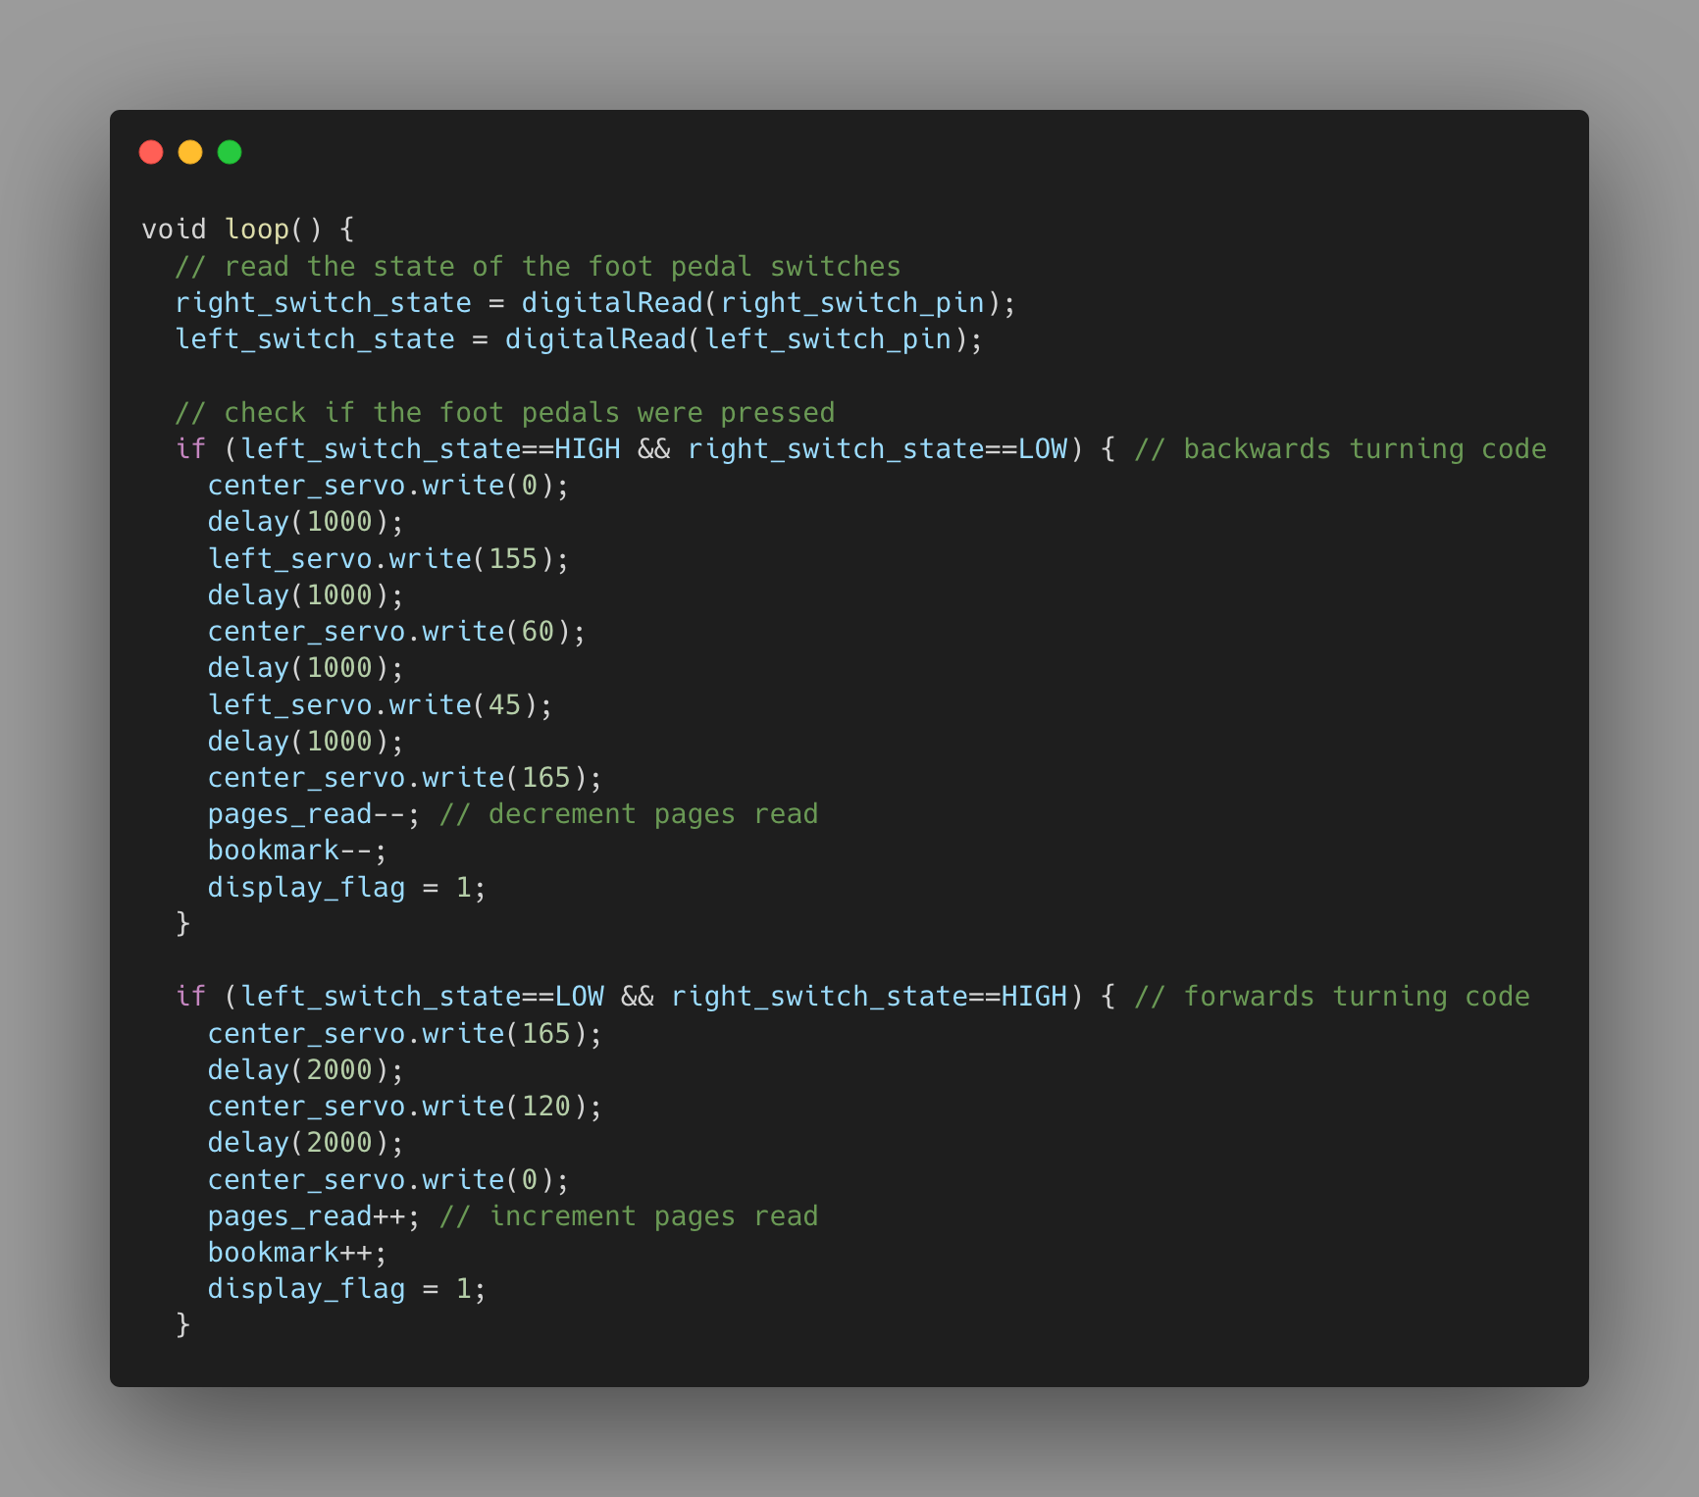

Figure 7: Device Code Continued

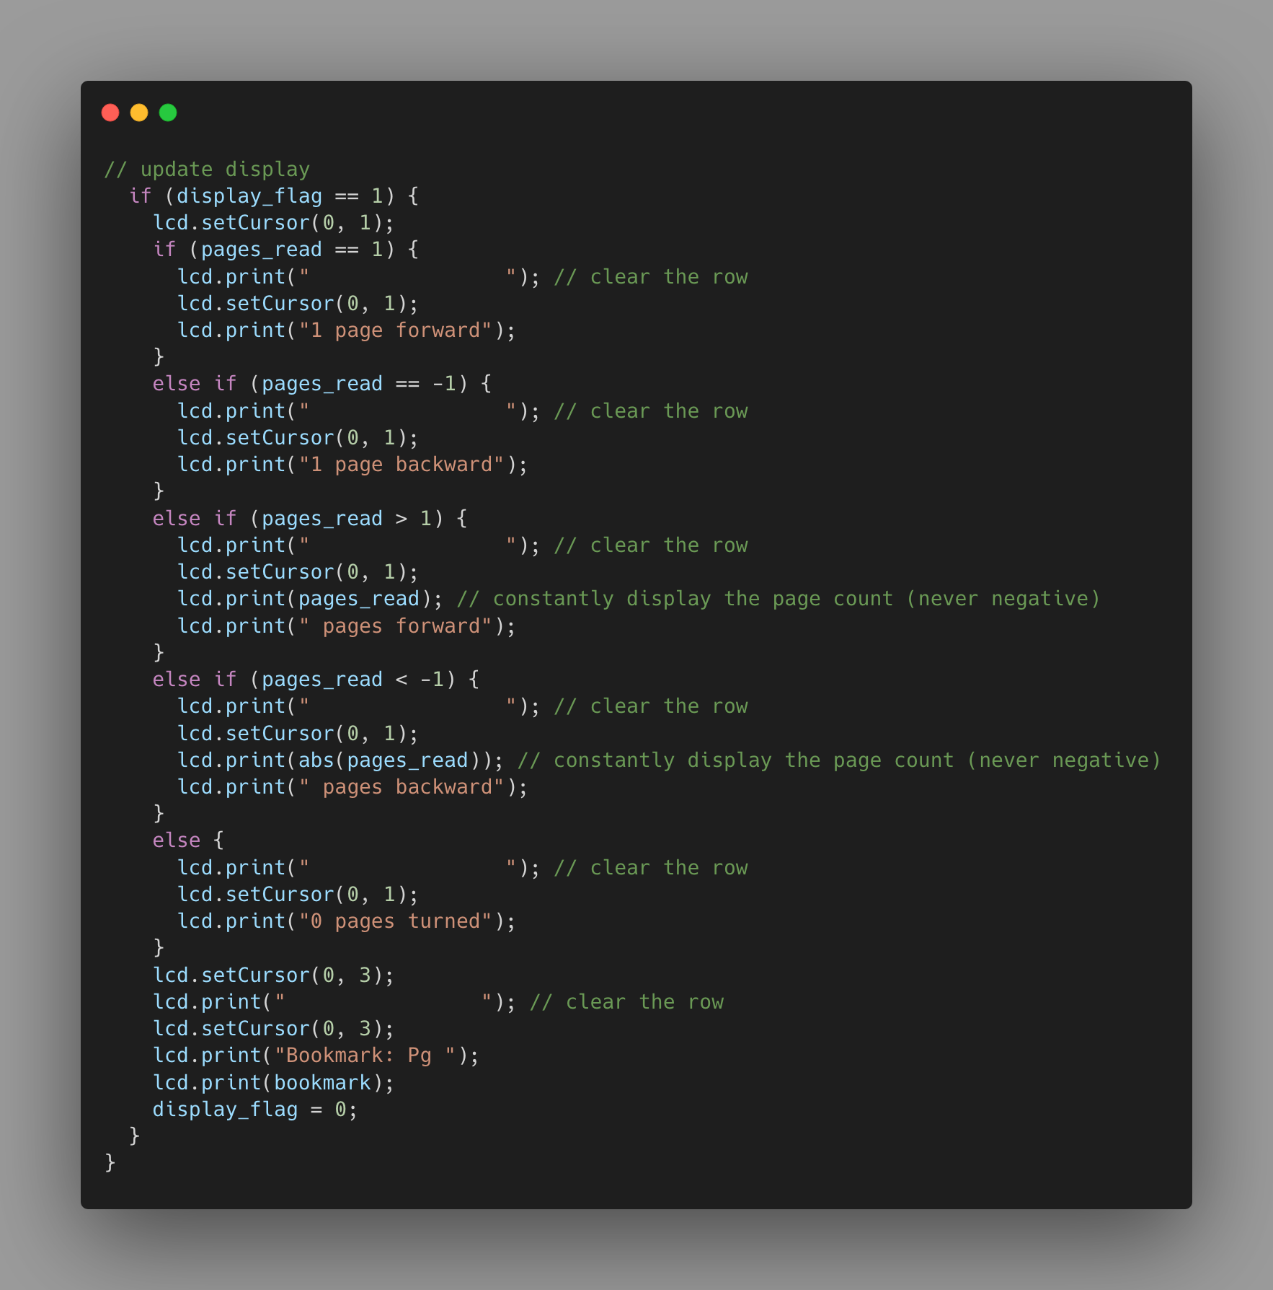

Figure 7: Device Code Continued

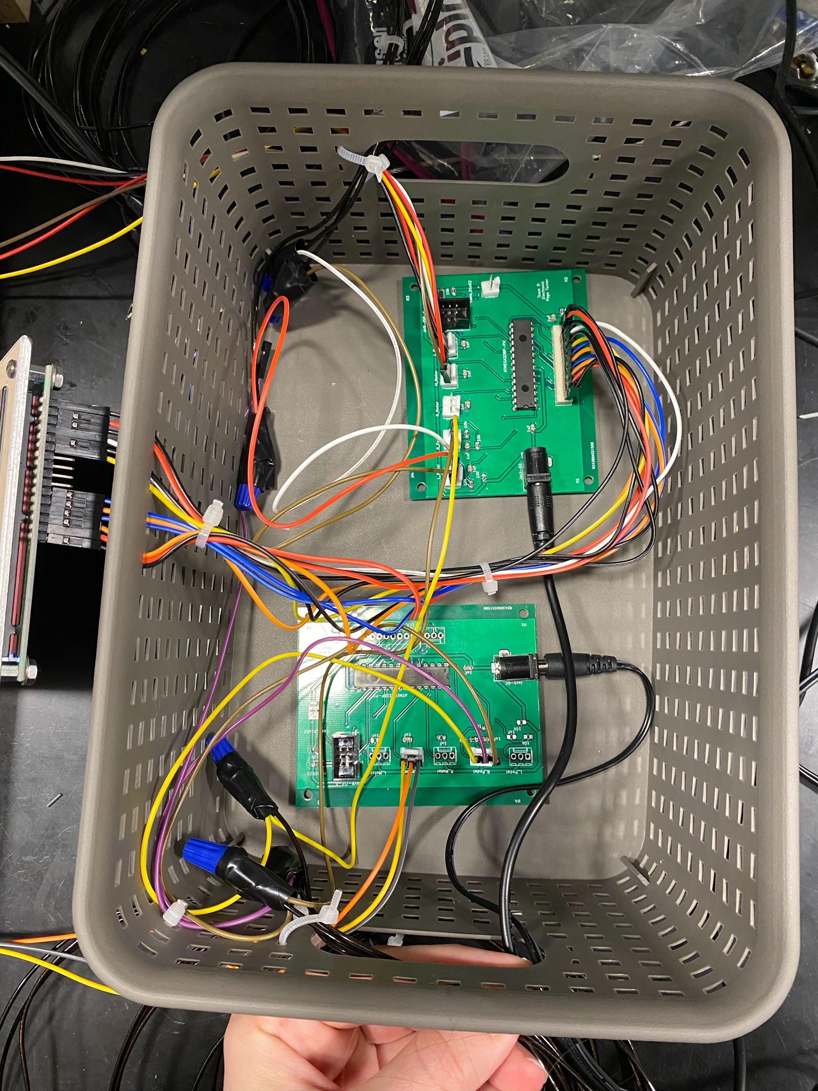

Figure 8: Final PCBs

## 

Figure 9: Software Flowchart

## 

## Figure 10: Circuit Schematic

## 

## Figure 11: PCB Schematic

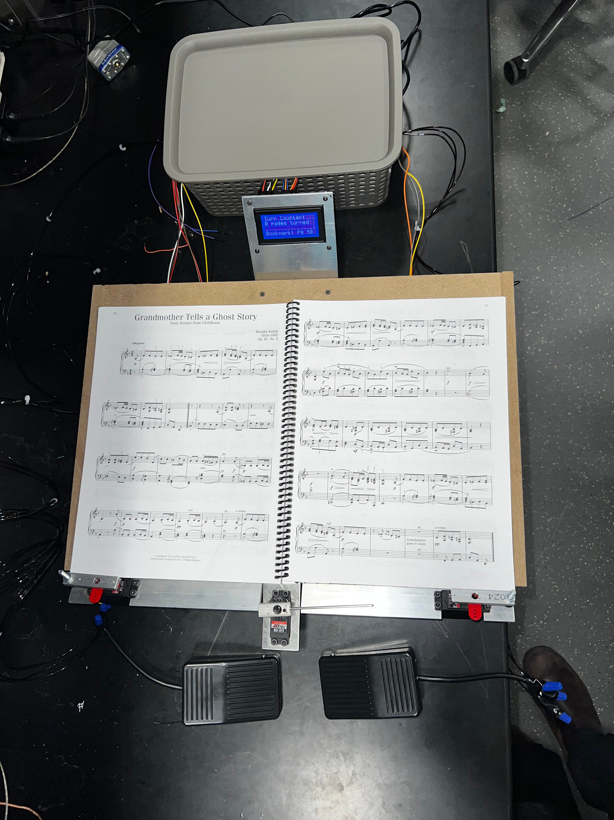

Figure 13: Final Product